

**Music Mart**

COSC 412 Individual Project

By: Jeff Sabol

Towson University

Rebecca Broadwater

COSC 412 Fall 2020

Preface: To provide an alternative market for music selling that doesn’t not involve revenue cuts

Revisions:

10/30/2020 – Name change, Github repo change, Tools selection change (azure), domain created: musicmart.live

Table of Contents

Part 1: **Introduction**

1.1 Project Overview ........................................................................................................... **3**

1.2 Project Deliverables ....................................................................................................... **3**

1.3 Evolution of the SPMP ................................................................................................... **3**

1.4 Reference Materials ....................................................................................................... **3**

1.5 Definitions and Acronyms .............................................................................................. **3**

Part 2: **Project Organization**

2.1 Process Model ............................................................................................................... **4**

2.2 Organizational Structure ................................................................................................. **4**

2.3 Organizational Interface ................................................................................................. **4**

2.4 Project Responsibilities .................................................................................................. **4**

Part 3: **Managerial Process**

3.1 Management Objectives and Priorities ............................................................................. **5**

3.2 Assumptions, Dependencies, and Constraints …........................................................ **5**

3.3 Risk Management .......................................................................................................... **5**

3.4 Monitoring and Controlling Mechanisms ......................................................................... **5**

3.5 Staffing Plan …........................................................................................................... **5**

Part 4: **Technical Process**

4.1 Methods, Tools, and Techniques ..................................................................................... **6**

4.2 Software Documentation ................................................................................................ **6**

4.3 Project Support Functions ............................................................................................... **6**

Part 5: **Description of Work Packages**

Work Breakdown Structure (WBS) ....................................................................................... **7**

Project Schedule .................................................................................................................. **7**

**Part 1: Introduction**

1.1 Project Overview

Music Mart is an E-commerce market to sell and buy music, but 100% of the revenue goes to the seller.

When trying to sell music online, every music store will take a certain cut from the musicians’ revenue. Unlike other music stores, Music Mart will not take a cut from the musicians’ revenue.

1.2 Project Deliverables

Topic Proposal – 9/6/2020

SPMP – 10/2/2020

Tool Selection Review – 10/2/2020

Design Review – Date to be determined with client

Individual Project Due – 11/16/2020

Individual Project Presentations Part I – 11/30/2020

Individual Project Presentations Part II – 12/7/2020

1.3 Evolution of the SPMP

Music Mart updates will rely based on what the user wants and needs. The client will be in contact to makes sure everything is satisfied regarding the software.

1.4 Reference Materials

N/A

1.5 Definitions and Acronyms

Database: A collection of data which will be used for holding data such as artist information.

Kentico: The contact management system used for this project.

**Part 2: Project Organization**

2.1 Process Model

* Requirement Specification
* Use Case Analysis
* System Design and Integration
* Build Prototype
* Testing
* Refine Prototype
* Deliver Final Version

2.2 Organizational Structure

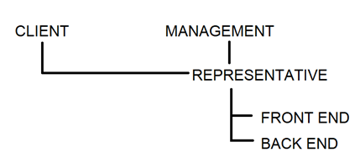

2.3 Organizational Interfaces

[BitBucket Repo](https://bitbucket.org/asdfJeff/cutfreemusicmarket/src/master/), Git, Wordpress

2.4 Project Responsibilities

Everything – Jeff Sabol

**Part 3: Managerial Process**

3.1 Management Objectives and Priorities

Music Mart will keep a close relation with the client to make sure all needs and requirements are met. Customers will be able to contact and email support if needed. There is also a contact link on the website for customers to use.

3.2 Assumptions, Dependencies, and Constraints

This project is under a time constraint, it must be completed by November 28th by midnight. Constraints with Kentico and Microsoft Azure relations may arise. Broadband limits may constrain data usage.

3.3 Risk Management

The project must be completed by 11/30, and 12/7 for presentations. Some features may need to leave out to fit the budget and time constraint. Streaming data could cause unexpected broadcast expenses.

3.4 Monitoring and Controlling Mechanisms

Updates on the project will be provided via the link to its GitHub. This can be checked at anytime.

3.5 Staffing Plan

N/A

**Part 4: Technical Process**

4.1 Methods, Tools, and Techniques

GitHub, HTML, CSS, C#, MySQL, Kentico, Microsoft Azure,

<https://github.com/JeffSabol/MusicMart>

4.2 Software Documentation

The SPMP and revision sheet will be documented with all updates. Github will also have a list of updates and commits.

4.3 Project Support Functions

To ensure quality assurance we will be working and communicating with the client closely to make sure all needs and wants are met. Testing will be done to ensure all features work as intended.

**Part 5: Description of Work Packages**

Work-Breakdown Structure:

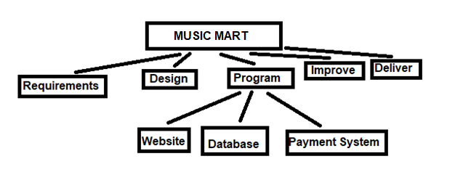

Project Schedule

Timeline:

